**COMPUTER SCIENCE DEPARTMENT**

LAB: Database System

**Lab task # 03**

**Last date of Submission: 25th October 2024**

# Submitted To: Mam Kashia Riaz

**Student Name: UBAID-BIN-WARIS**

# Reg. Number: 2212416

# 

**Q no.1**

Create the Given table by using basic queries in MYSQL Workbench.

**Solution**

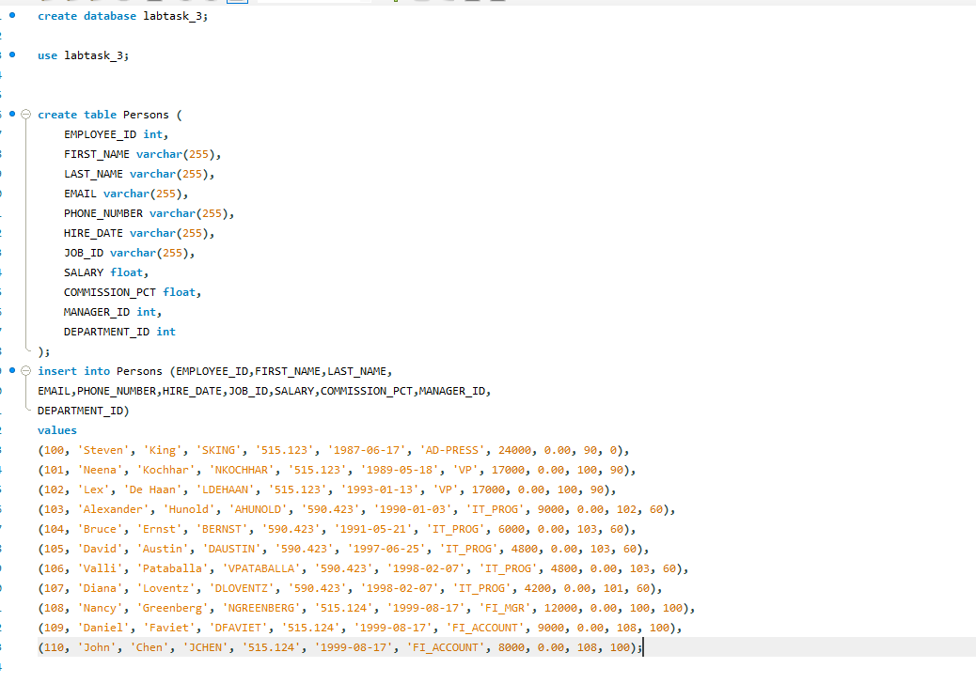

**Q no.2**

**PART A**

Write an SQL statement to change salary of employee 8000 whose ID is 105, if the existing salary is less then 5000.

**Solution**

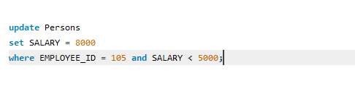

**PART B**

Write an SQL statement to change job_ID of employee which ID is 118 to SH_CLERK if the employee belongs to departmant, which ID is 30 and the existing job_ID does not start with SH.

**Solution**

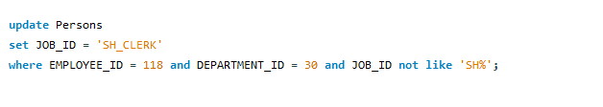

**Q no.3**

Create the Given table by using basic queries in MYSQL Workbench.

**Solution**

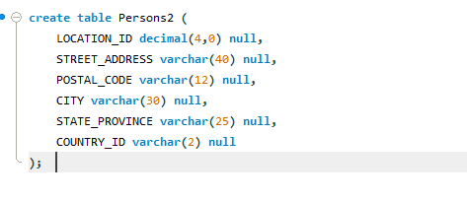

**Q no.4**

Write a SQL statement to add a column region_id to the table locations.

Write a SQL statement to add a columns ID as the first column of the table locations.

Write a SQL statement to add a column region_id after state_province to the table locations.

Write a SQL statement change the data type of the column country_id to integer in the table locations.

Write a SQL statement to drop the column city from the table locations

**Solution**

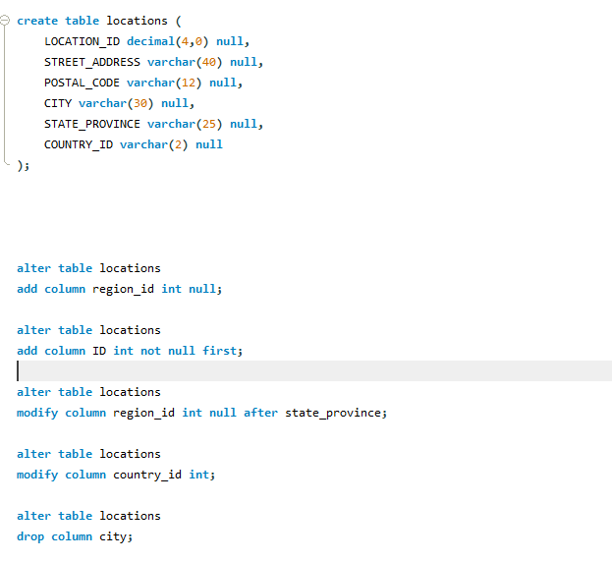

**Q no.5**

Apply all the discussed constraints on the created database according to your choice.

**Solution**

